**Data Business Consultancy Project**

**Video Game**

*By* Meiru Zhong

**Content**

**1. Business Value 1**

**2. Data Analysis 1**

2.1 How many video games’ global sales exceed one million? 1

2.2 What are the Top 10 video games with the highest sales in Europe? 3

2.3 Comparison of global sales of three publishers 4

2.4 List of video games 5

2.5 Introduction of video games 6

# 1. Business Value

For this project, we analyze the sales of three types of games including Simulation, Fighting, and Strategy, by three companies, which are Nintendo, Microsoft Game Studios, and Sony Computer Entertainment, in different regions of the world. Our goal is to provide marketing strategies to gaming-producing companies.

# 2. Data Analysis

## 2.1 How many video games’ global sales exceed one million?

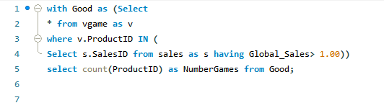

This query includes **With, Subquery in the WHERE clause, In, and Having.**

* **With:** Filter the data on the basis of the original table, then put the filtered results in a temporarily named table, and then execute the query on this temporary table.
* **Subquery in the WHERE clause:** First filter out objects that meet a certain condition, and then use the query result as an IN list item to achieve the final query result.
* **In:** operator allows you to specify multiple values in a WHERE clause.
* **Having:** The HAVING clause was added because the WHERE keyword cannot be used with aggregate functions.

**Or**

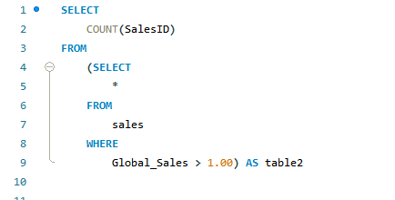

This query includes **Subquery in the FROM clause**.

* **Subquery in the FROM clause:** Filter based on the original table, and then execute other statements from the filtered data, such as extracting data or performing calculations.

**Or**

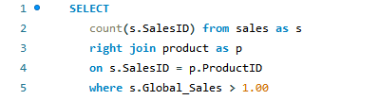

This query includes **Right Join.**

* **Right Join:** All data are extracted from the right table and the matching one from the left table. If there is no matching record from the left table, the results from the left will be 0.



**There are 48 (27%) video games’ global sales exceeding one million.**

## 2.2 What are the Top 10 video games with the highest sales in Europe?

Top 10 video games in Europe

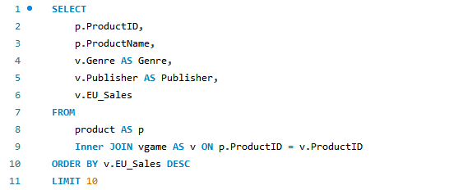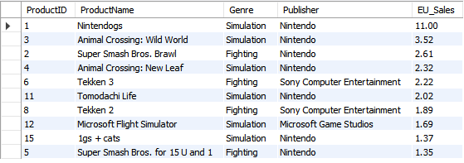

This query includes **Inner Join.**

**Inner Join**：keyword selects records that have matching values in both tables.

## 2.3 Comparison of global sales of three publishers

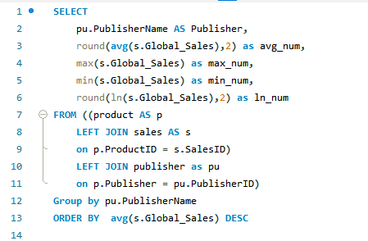

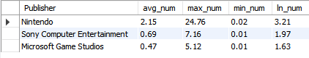

This query includes **Round, Average, Max, Min, LN, and Left Join.**

* **Round:** rounds a number to a specified number of decimal places.
* **Average:** the average of the selected data is required.
* **Max:** the function returns the largest value of the selected column.
* **Min:** the function returns the smallest value of the selected column.
* **LN:** the function returns the logarithmic value of the selected column.
* **Left Join:** the data in the left table is completely selected and matched the data in the right table. If not matched, the result is null.

## 2.4 List of video games

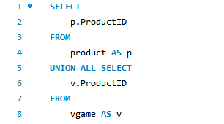

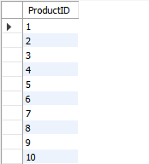

This query includes **Union.**

* **Union:** Combine the results of two or more tables in one with the same structure, the same number of columns, the same order, and similar data types for columns. Generally, Execute **Union Function** will export records with duplicate results deleted, while Execute **Union All** will export all data.

## 2.5 Introduction of video games

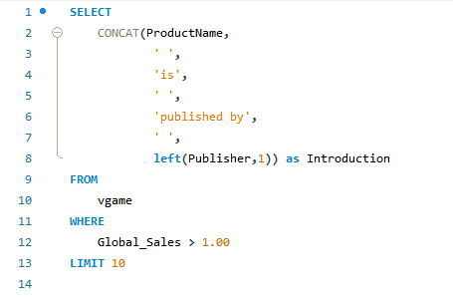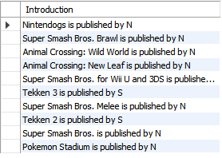

This query includes **String Function.**

* **Concat:** stings are added together.
* **Left:** Starting from the left, one letter of the string is extracted.